**TASK 7 – Checking Browser Extensions**

**Steps involved in checking for suspicious browser extensions**

1. Open a web browser
2. Click on the Extensions icon from the right corner of the web browser

1. Click on the manage extensions button

1. The extensions are displayed

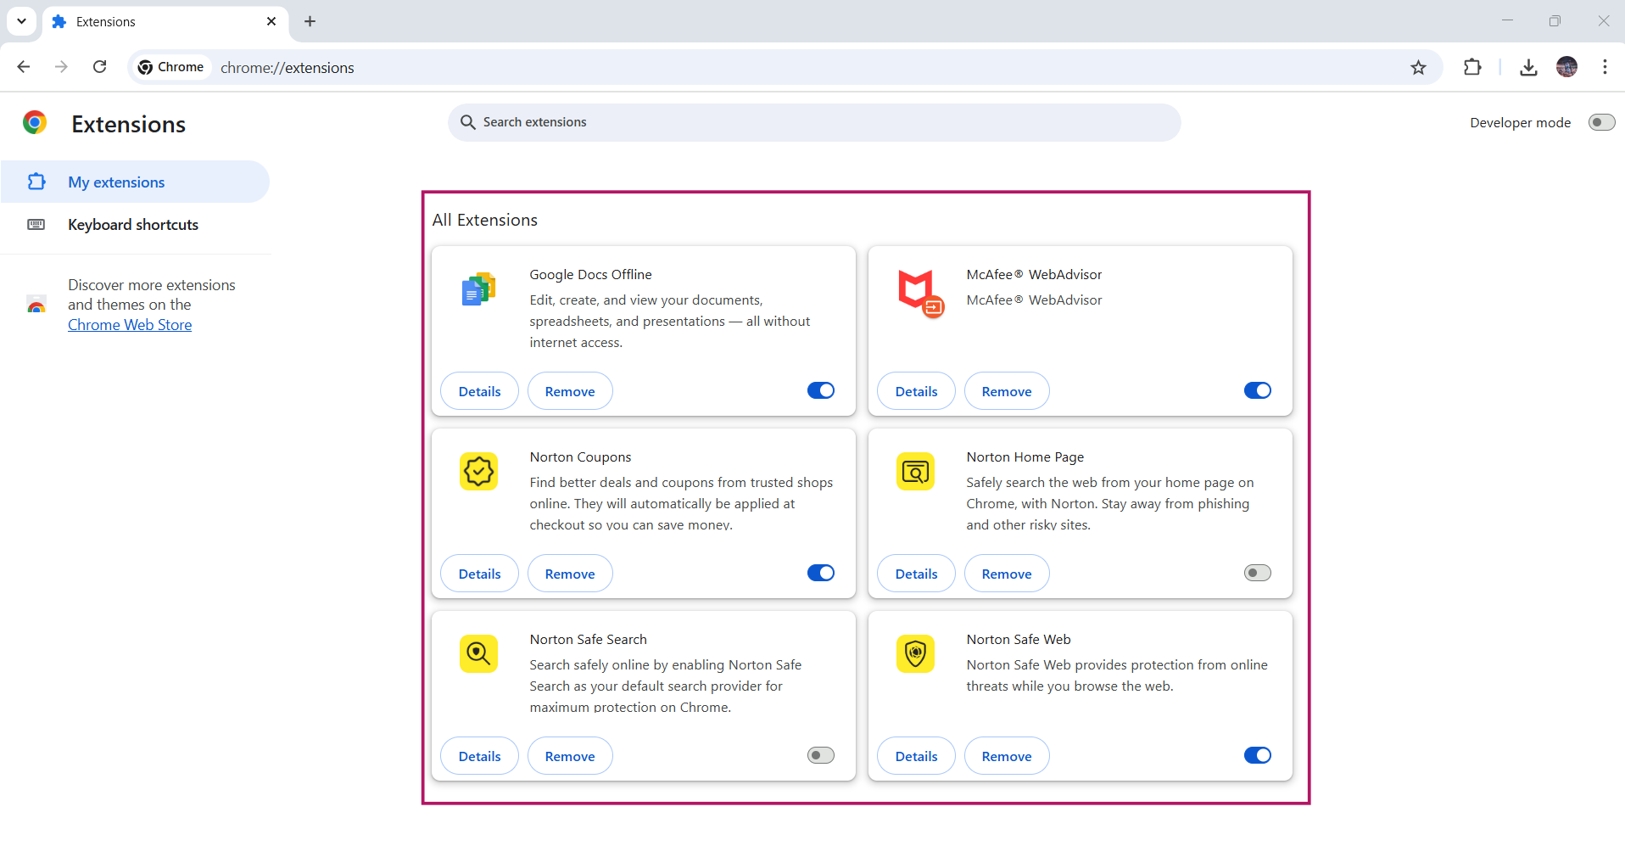

1. The Google Docs Offline extension looks fine, nothing suspicious

1. The McAfee WebAdvisor extension looks good

1. The Norton extensions are used because of my subscription

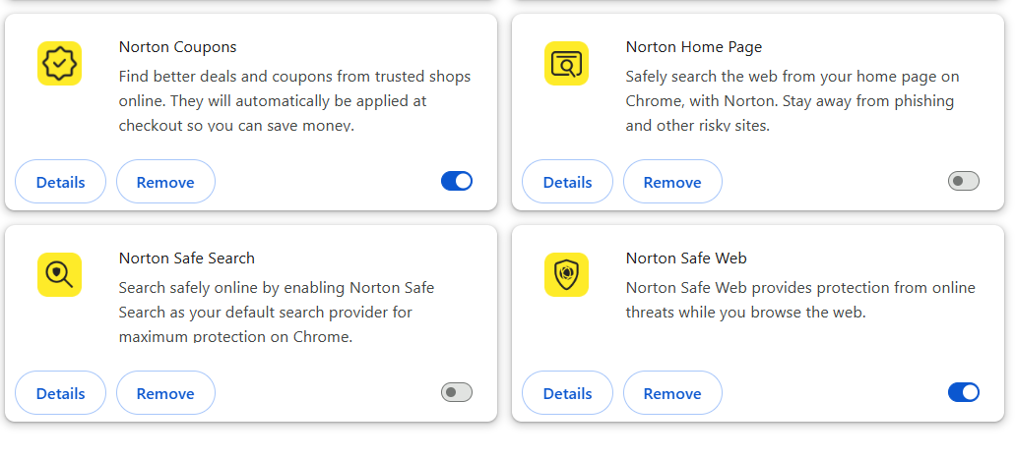

1. Therefore, the extensions that are used in my web browser are safe and useful, which are either available by default or downloaded by me for my privacy and security purposes
2. If there is any extension that looks suspicious or not used by you or not downloaded by you, it is crucial to remove such extensions after thorough analysis by going through the permissions and the reviews of those extensions
3. Always install extensions from the official marketplaces, check the permissions listed on the extension for relevance